Python – Machine Learning - Functions to Remember

from sklearn.tree import DecisionTreeRegressor

model = DecisionTreeRegressor(random_state = 1)

model.fit(X, y)

* X is the data, y is the output from the data. Creates a model called model which can be used to predict further data.

Predictions = model.predict(X)

* Predicts the output for some Data X, based on the model computed above.

from sklearn.model_selection import train_test_split

train_X, val_X, train_y, val_y = train_test_split(X, y, random_state=1)

* train_test_split splits the data into 4 categories , the training data and output and the validation data and output. Splits it equally 50-50.

from sklearn.metrics import mean_absolute_error

mean_absolute_error(val_y, val_predictions)

* Gives the mean absolute error between predictions and real values.

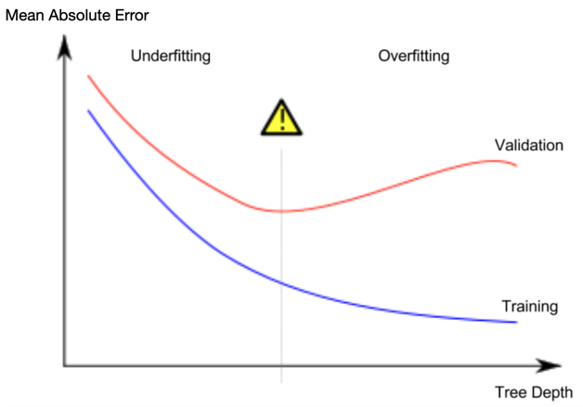- showing difference between overfitting and underfitting.

model = DecisionTreeRegressor(max_leaf_nodes=100, random_state=0)

* This function here inputs max_leaf, which tell you how many levels deep the machine learning should go, it affects overfitting and underfitting, you can change it to find the optimal absolute mean error to get the best machine learning algorithm